**ABSTRACT**

A wheelchair is a mechanically operated device used by physically challenged people to move on their own. This voice-controlled wheelchair minimizes their effort and makes it easy for them to use. Basically, a wheelchair is used to move from one place to another. The smart wheelchair has voice commands, which makes it a lot easier. They are handy while exploring. The main use of smart wheelchairs is that they have a GPS tracker and voice commands for movements. Many kinds of wheelchairs were invented in the past, but this would be a lot more advanced.

**OBJECTIVES**

The objective of a voice-controlled wheelchair is to enhance mobility and independence for individuals with physical disabilities by providing a hands-free control system that responds to voice commands. Key goals include:

1. Improving Accessibility: By enabling users to control the wheelchair through simple voice commands, the system is especially beneficial for individuals with limited hand or arm mobility, reducing the need for physical controls like joysticks or buttons.

2. Enhancing Autonomy: A voice-controlled wheelchair empowers users to navigate their environment independently, promoting self-reliance and reducing the need for constant caregiver assistance.

3. Increasing Ease of Use: Voice commands offer a simple and intuitive interface, allowing users to move forward, backward, turn, and stop the wheelchair with ease. This simplicity makes the wheelchair accessible for users of all ages and abilities.

4. Boosting Safety: With the potential to integrate features like obstacle detection and emergency stopping, a voice-controlled wheelchair can enhance user safety by providing real-time navigation assistance and collision avoidance.

5. Enabling Customization and Flexibility: Voice-controlled systems can be customized to recognize specific commands and can be integrated with smart home devices, allowing for seamless control over both mobility and other assistive systems.

**CHAPTER 1**

**INTRODUCTION**

The video provides a comprehensive look at a **voice-controlled wheelchair** powered by the **ESP32 microcontroller**—a low-cost, versatile chip that enables voice recognition and motor control for enhanced mobility assistance. This setup aims to help individuals with physical disabilities navigate independently by interpreting voice commands to control the wheelchair’s movement.

The wheelchair moves based on voice commands like "forward," "backward," "left," and "right." These commands are processed through the ESP32, which acts as the main controller. The ESP32 is widely used in IoT and embedded applications because of its integrated Wi-Fi and Bluetooth capabilities, making it ideal for this project due to its ability to handle both local voice commands and potentially connect to external devices for added functionality.

The ESP32 listens for voice input, either through a microphone connected directly to it or via a paired device, such as a smartphone. The recognized command is translated into electrical signals that direct the wheelchair’s motors. When a command is received, the ESP32 sends signals to the motor driver circuit, which controls the speed and direction of the motors, allowing the wheelchair to move accordingly.

This setup is especially beneficial for individuals with limited hand or arm mobility, as it eliminates the need for physical controls like joysticks or buttons. The voice control mechanism allows users to navigate in various directions and even stop with simple spoken instructions. Additionally, the use of ESP32 enables potential for other features like obstacle detection, GPS tracking, and remote monitoring, which could further enhance the wheelchair's functionality and user safety.

**CHAPTER 2**

**LITERATURE SURVEY**

**Literature Survey on Voice-Controlled Wheelchairs**

| **Journal/Conference** | **Title** | **Methods Used** | **Key Inferences** |
| --- | --- | --- | --- |
| International Journal of Engineering Research & Technology | An Voice-Controlled Wheelchair for Physically Challenged People with Therapy Unit | Voice recognition module, microcontroller, motor control | The system successfully enabled voice-controlled movement and included a therapy unit for rehabilitation exercises. |
| IARJSET | Voice-Controlled Smart Wheelchair For Physically Disabled Person | Arduino Uno, voice recognition module, ultrasonic sensors, Bluetooth module | The system demonstrated effective voice control and obstacle avoidance capabilities, offering enhanced mobility and safety. |
| ResearchGate | Voice-controlled wheelchair | Arduino microcontroller, voice recognition module, motor control | This system successfully implemented voice-controlled movement, providing a basic solution for independent mobility. |
| IEEE | Voice-Controlled Wheelchair Using Deep Learning and IoT | Deep learning for voice recognition, IoT for remote monitoring | The integration of deep learning improved voice recognition accuracy, while IoT enabled remote monitoring and control of the wheelchair. |
| ACM | A Survey on Voice-Controlled Wheelchair Systems | Literature review, system analysis, future directions | This survey identified key challenges and future research directions, including improving voice recognition accuracy, obstacle avoidance, and user interface design. |

**CHAPTER 3**

**SYSTEM DESCRIPTION**

**HARDWARE SPECIFICATIONS**

1. **ESP32**

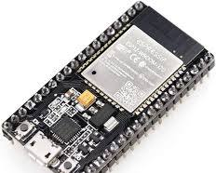

The ESP32 is a powerful and versatile microcontroller developed by Espressif Systems. It's particularly popular for IoT (Internet of Things) projects due to its low cost, low power consumption, and integrated Wi-Fi and Bluetooth capabilities.

1. **Voice Recognition V3 Module**

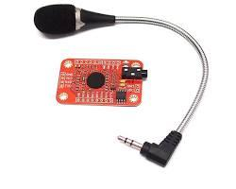

The Voice Recognition Module V3 is a compact and easy-to-use device that can recognize and respond to spoken commands. It's perfect for creating voice-controlled projects, such as home automation systems, robots, and interactive toys.

1. **L298n Motor Driver**

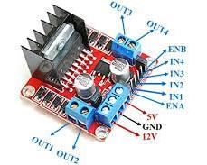

The L298N is a popular motor driver IC that allows you to control the speed and direction of two DC motors. The L298N uses H-bridge configurations to switch the polarity of the voltage applied to the motor, allowing for both forward and reverse rotation. By controlling the duty cycle of the PWM signal applied to the enable pins, you can adjust the motor's speed.

1. **Gear Motor**

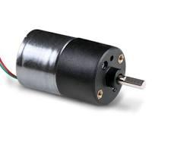

A gear motor is an electric motor that is coupled with a gearbox. This gearbox, a set of gears of different sizes, reduces the motor's speed while increasing its torque. Gear motors are essential components in many mechanical systems, providing the necessary power and control for a wide range of applications.

1. **12V LED**



A 12V LED (light-emitting diode) is a type of LED designed to operate on a 12-volt direct current (DC) power supply. These LEDs are commonly used in various applications due to their energy efficiency, long lifespan, and durability.

**(f) 7-12 V DC BATTERY**

A 7-12V DC LiPo battery typically refers to a 2S (7.4V) or 3S (11.1V) LiPo battery pack. These packs provide stable power for devices like RC vehicles, drones, and robotics. The voltage range varies as they discharge, so a voltage regulator may be necessary if a constant 7-12V output is required.



**SOFTWARE SPECIFICATIONS**

**Arduino ide**

Arduino is an open-source platform used for building electronics projects. Arduino consists of both a physical programmable circuit board (often referred to as a microcontroller) and a piece of software, or IDE (Integrated Development Environment), that runs on your computer and is used to write and upload computer code to the physical board. The Arduino platform has become quite popular with people just starting and anyone interested in creating interactive objects or environments. Arduino can interact with buttons, LEDs, motors, speakers, GPS units, cameras, the internet, and even your smart phone or your TV! This flexibility combined with the fact that the Arduino software is free, the hardware boards are pretty cheap, and both the software and hardware are easy to learn has led to a large community of users who have contributed code and released instructions for a huge variety of Arduino-based projects

There are many varieties of Arduino boards (explained on the next page) that can be used for different purposes. Some boards look a bit different from the one below, but most Arduinos have the majority of these components in common.



**Block diagram**

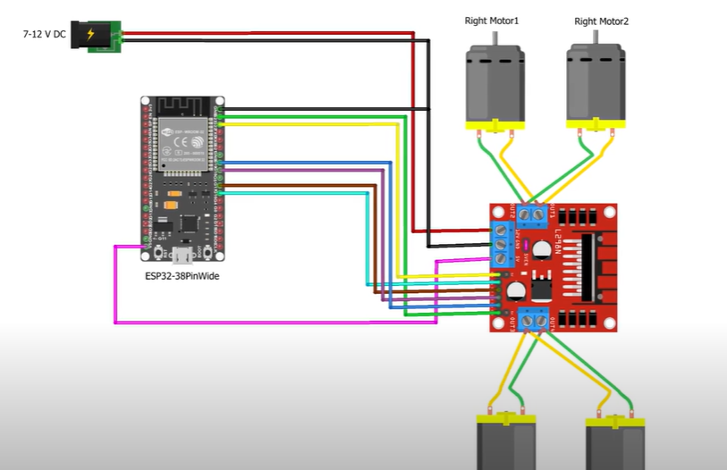

**CHAPTER 4**

**METHODOLOGY**

**Direct Voice Recognition on ESP32:** If a dedicated voice recognition module is attached, it will detect and classify spoken commands, such as "forward," "backward," "left," "right," and "stop." The module processes these commands and sends them as digital signals to the ESP32.

**Smartphone App Integration**: The ESP32 connects to a smartphone app via Bluetooth, where the phone’s voice recognition capabilities convert spoken commands into text or simple signals that are sent to the ESP32. This method leverages the advanced processing power of the smartphone for accurate voice recognition.

### Programming the ESP32

The ESP32 is programmed using **the Arduino IDE** or **MicroPython** to process incoming voice commands and send control signals to the motor driver. The program includes:

* **Command Mapping**: Predefined voice commands are mapped to specific actions. For example, "forward" increases motor speed in both wheels, "left" reduces speed in one wheel, and "stop" cuts power to the motors.
* **Control Logic**: The ESP32 interprets voice commands and generates appropriate pulse-width modulation (PWM) signals for the motor driver. The control logic ensures smooth acceleration, braking, and turning.
* **Error Handling**: If unrecognized commands are received, the program is designed to ignore them or prompt the user for clarification.

### Motor Control and Navigation

The motor driver module receives PWM signals from the ESP32 to control the wheelchair’s motors. Based on the PWM duty cycle, the driver adjusts the motor speed and direction, allowing for smooth forward, backward, left, and right movements.

For each command, the ESP32 calculates the required speed and direction for each motor. For example, to turn left, the right motor will spin faster than the left one.

### Final Integration and Optimization

Once testing is complete, the entire system is integrated into the wheelchair. Components are securely mounted, and wiring is organized for durability and easy access. The final software is fine-tuned, with any remaining bugs addressed. If using a smartphone app, its interface is optimized to be intuitive and accessible for the user.

**Hardware model development**

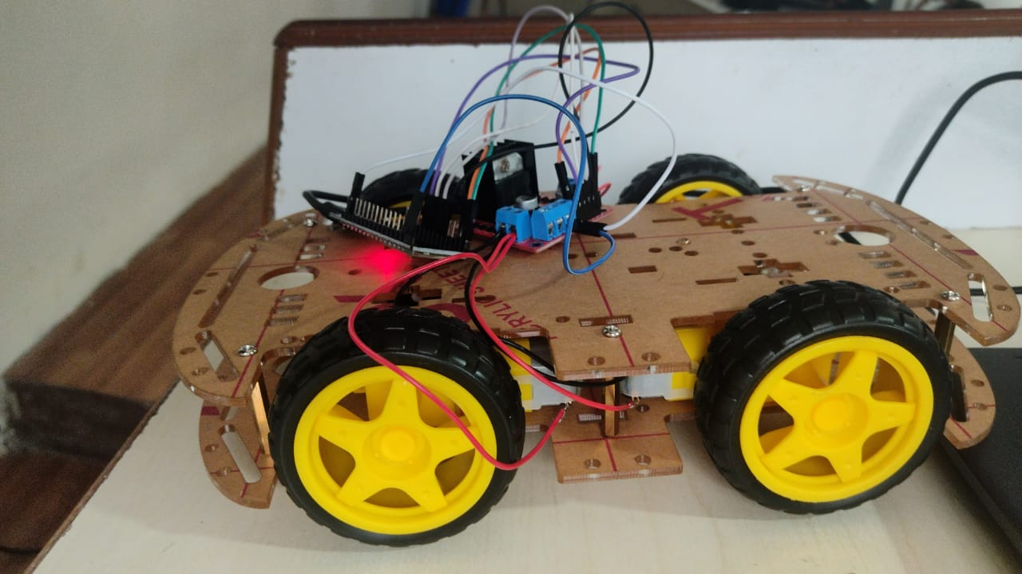

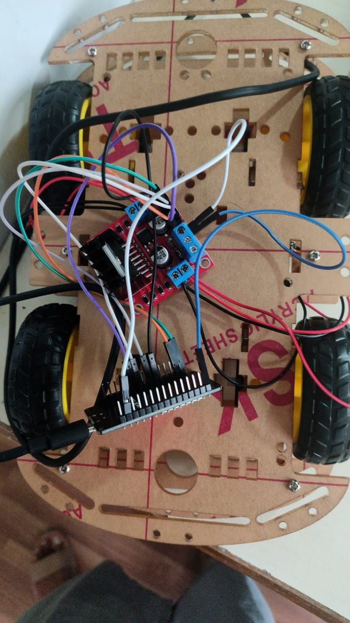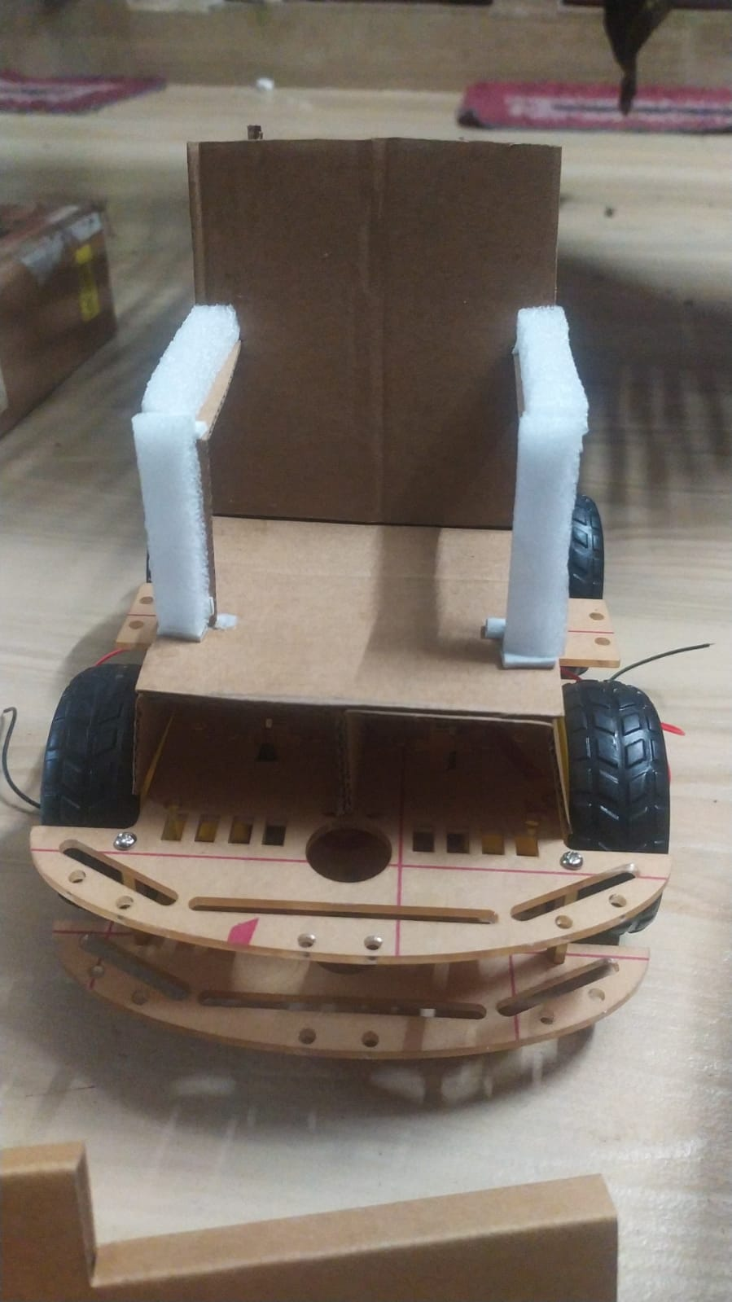

**CHAPTER 5**

**CONCLUSION**

A voice-controlled wheelchair using the ESP32 offers a highly accessible and affordable solution for individuals with mobility challenges. By integrating voice recognition with the ESP32 microcontroller, users can control the wheelchair's movements through simple voice commands. The ESP32's Wi-Fi and Bluetooth capabilities allow for easy integration with voice assistant platforms, enhancing the system's flexibility and range. This design reduces the need for physical controls, making it suitable for users with limited hand or arm mobility, and it opens the door for further customization, such as remote monitoring and obstacle detection. Overall, this project demonstrates a promising approach to improving mobility assistance with cost-effective, user-friendly technology.

**REFERENCES**

1. Md Abdullah Al Rakib, Salah Uddin, Md. Moklesur Rahman, Shantanu Chakraborty, Md. Ashiqur Rahman, and Fysol Ibna Abbas, European Journal of Engineering and Technology Research ISSN: 2736-576X Smart Wheelchair with Voice Control for Physically Challenged People
2. Shoeb Khan, Neamat Ansari ,Md. Mudassir, Safi Nazimuddin, and Geeta Desai, International Journal of Computer Applications—Voice-Controlled Wheelchair with Home Automation.
3. [Voice Controlled Bluetooth Car 🎤DIY | esp32](https://youtu.be/n1jtOkvu6c8?si=xLyJWnl0eE35EtdJ)